

Pi in the Sky

by

Martha Adcock

martha.adcock@mymail.champlain.edu

My submission of this assignment acknowledges I have read, understand, and agree to abide by Champlain College’s Academic Honesty Policy. I declare that all work within this assignment is my own or appropriately attributed. I accept failure to abide by Champlain College’s Academic Honesty Policy may result in disciplinary action, including dismissal.

Date Due: December 11, 2022

Date Submitted: December 10, 2022

Table of Contents

Hypothesis 3

Antenna Information 3

Test Design 5

Required Materials 6

Physical Equipment 6

Software 8

Procedure 9

Results 15

The Recorded Data 15

The Omnidirectional (Dipole) Antenna 15

Dipole Results 18

Semi-Directional Antenna (Panel) 18

Semi-Directional Antenna Results 20

A ”More” Directional Antenna (Yagi) 20

Yagi Antenna Results 22

Comparing the antennas 22

RSSI 22

File Transfer Time 23

Conclusion 23

References: 24

Appendix 26

Raw data collected during the test 26

Spreadsheet with data and graph sources 26

Program from network client 26

Program from server computer 26

Webserver.py Endpoint Information 26

Post Endpoints 26

Get Endpoints 27

Determining spacing between client stations 28

# Hypothesis

The strength of wireless network signal and the associated network throughput for a client in a 2.4 GHz wireless local area network (WLAN) is impacted by the type of antenna used on the wireless access point (WAP) and the relative location of the network client to that antenna. This project will examine the received signal strength and throughput of dipole, panel, and Yagi antennas.

# Antenna Information

Dipole antennas are omnidirectional antennas, which are simple to use, and have a wide range of applications. “In its simplest form, it consists of two pieces of thin conducting wires that have a gap between them (Ali, 2021).” Figure 1 shows the radiation pattern of a dipole antenna. While they are known as omnidirectional antennas, the radiation patterns are not truly omnidirectional. The mounting apparatus blocks and absorbs some of the radiation. Dipole antennas are a common choice for small office, home office (SOHO) applications.

**Figure 1**

*Dipole antenna radiation pattern (Ali, 2021)*

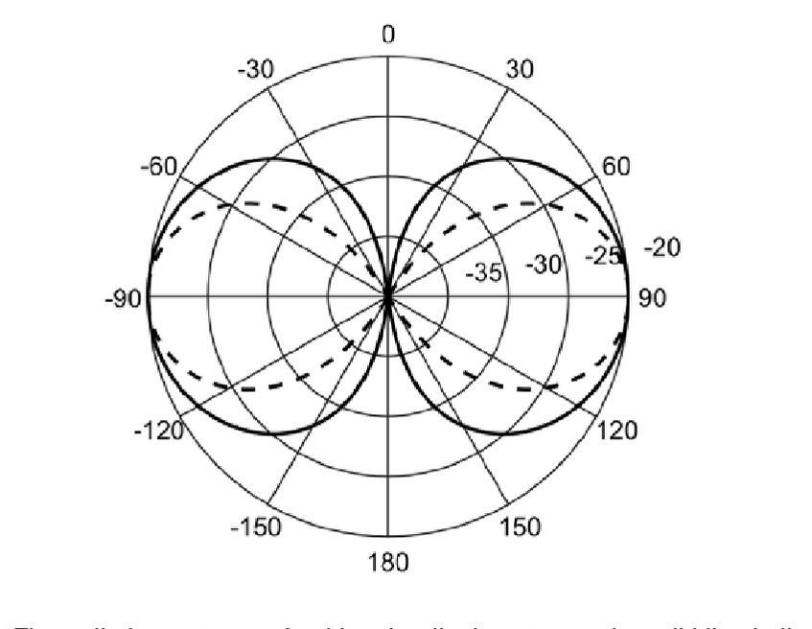

Panel, or patch antennas, are common names for a type of semi-directional antennas known as planar antennas. Planar antennas use “a very thin metallic strip placed on a ground plane with a di-electric material in-between. The radiating element and feed lines are placed by the process of photo-etching on the di-electric material (*Antenna theory - micro strip*, n.d.).” They are most commonly used indoors for unidirectional coverage (Westcott and Coleman, 2014). Figure 2 shows the radiation pattern of planar antenna.

**Figure 2**

*Planar radiation pattern* (*Antenna theory - micro strip*, n.d.)

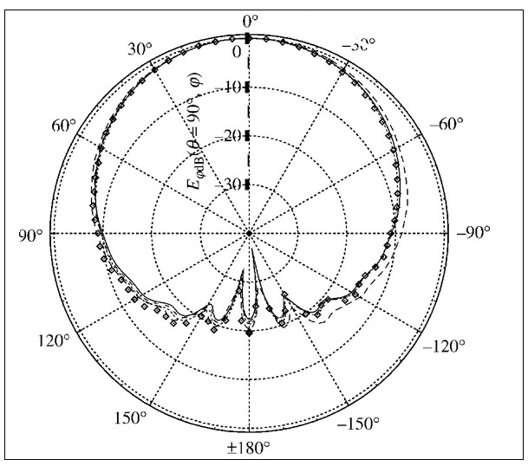

Another type of semi-directional antenna is a Yagi-Uda array antenna commonly called a Yagi. It is a directional array antenna. The Yagi radiation pattern is “of a main forward lobe and a number of spurious lobes to the rear and the side. The main spurious lobe is the reverse one caused by radiation in the direction of the reflector (*Yagi antenna / Yagi-Uda Aerial* n.d.).” It was a commonly seen fixture as television antennas on nearly every home in years past. Although they are classified as semi-directional antennas, the radiation pattern of Yagi antennas is more highly directional than planar antennas as seen in figure 3.

**Figure 3**

*Yagi radiation pattern* (*Yagi antenna gain, Directivity & Front to back ratio* n.d.)

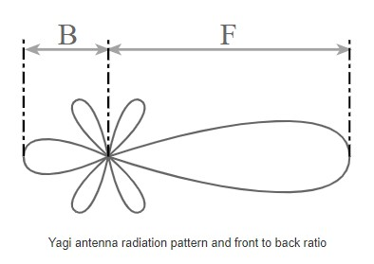

# Test Design

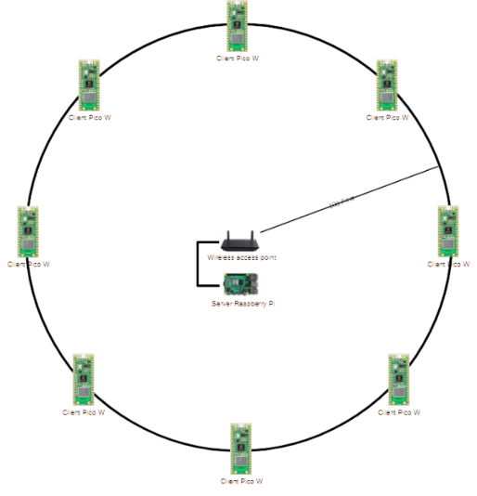 Create a wireless network (WLAN) around a 100-foot radius circle with eight client nodes spaced 45 degrees apart around the circle’s circumference (Figure 4). Place a wireless access point (WAP) and a wired server computer in the middle of the circle. Record the received signal strength indicator (RSSI) of each client and the time it takes the client to transfer a file to the server computer. Repeat this for each of the antenna types that will be connected to the WAP.

**Figure 4**

*WLAN with center AP and 8 client nodes*

To collect enough data to ensure temporary anomalies do not impact the overall result, the RSSI and file transfer times will be sampled every 15 seconds for 30 minutes for each antenna. This will result in 120 measurements of RSSI and file transfer times for each client for each access point antenna.

# Required Materials

## Physical Equipment

* 1x card table
* 1x lawn chair
* 1x 5-gallon bucket
* 100-foot tape measure
* 1x CyberPower CP1500AVRLCD UPS

**Figure 5**

*Cyberpower mini-tower UPS* (*CP1500AVRLCD*, 2022)

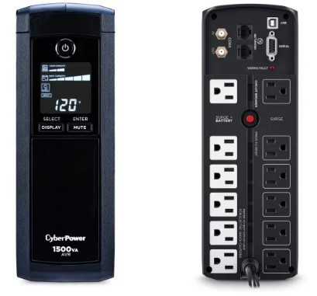

* 8x client network nodes – Raspberry Pi Pico Ws

**Figure 6**

*Raspberry Pi Pico W* (*New Pi Pico W- WIFI features, Specs & Pinout Simplified*, 2022)

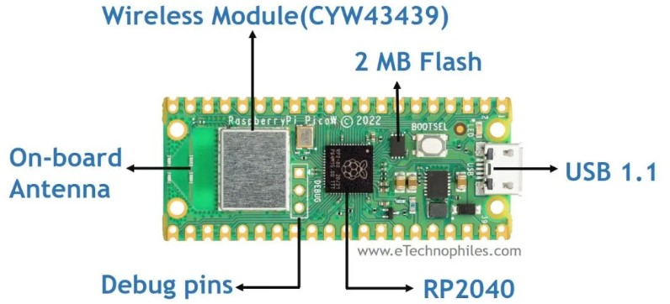

* + Battery pack for power: has on/off switch, holds 3 AAA batteries with USB cable
  + Cable from battery pack to Pico W, 6 ft micro-USB to USB
  + 3x AAA battery
  + 3x wooden dowel (3/8”x48”)
  + Battery pouch
  + Duct tape and string to build the stand and pouch

**Figure 7**

*Building materials for client node stands*

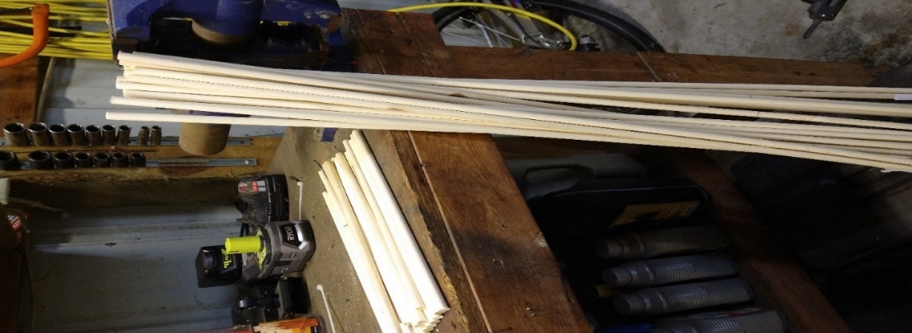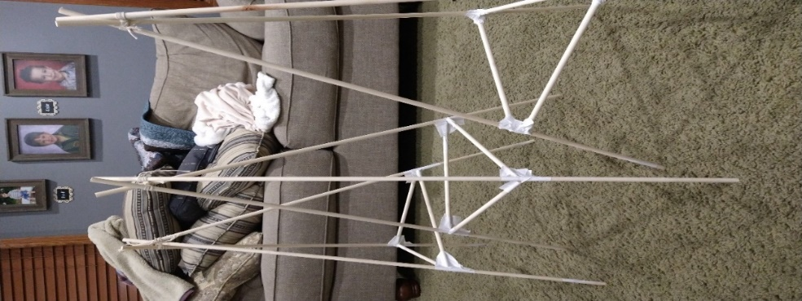

* 1x server computer - Raspberry Pi 4 8GB

**Figure 8**

Raspberry Pi 4 (*Raspberry Pi 4 GPIO pinout, Specs, schematic (detailed board layout),* 2021)

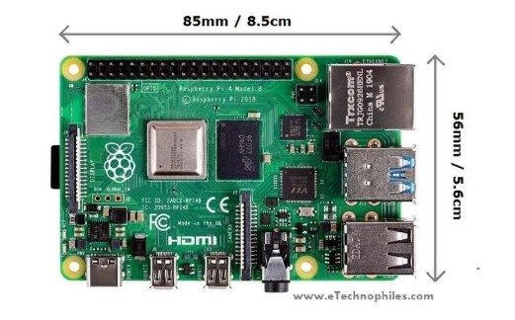

* + Power cord, case, SDHC card, ethernet cable
* 1x router - ASUS N300 Wi-Fi Router (RT-N12_D1, n.d.)
  + Power cord
* 1x laptop with power cord to monitor and control experiment
* 1x dipole antenna - 5dBi gain bundled with the router (RT-N12_D1, n.d.)
* 1x panel antenna - Alfa Networks APA-M25 8/10dBi gain panel antenna (*APA-M25*, n.d.)
* 1x Yagi antenna - TechToo 18dBi gain Yagi antenna (*TECHTOO WIFI 2.4ghz 18dbi high gain yagi directional ...*, n.d.)
  + A block of wood to secure the antenna

## Software

* Client node
  + MicroPython - Python runtime environment
  + Custom program that collects RSSI and file transfer times and reports them to the server computer
* Server node
  + Current version of Raspberry PI OS with VNC enabled (*Raspberry Pi os*, n.d.)
  + Thonny - Thonny is a free to use integrated development environment (IDE). It was developed with Python novices in mind. It allows for Python programming with built-in debugger ((Hardson-Hurley, n.d.).
  + Python 3.9
  + PyPi uploadserver running as a service with a detached console (*Find, install and publish python packages with the python package index*, n.d.)
  + Custom program dispatches configuration to the client computers and records metrics running as service with a detached console
* Laptop
  + MRemoteNG - An SSH client used to monitor experiment by watching the log file and console on the server computer (Majaly, 2022)
  + Insomnia - An HTTP client used to configure and control the experiment by interacting with the server computer web service endpoints (Mitra, 2021)
  + Thonny - Connect the laptop to the Raspberry Pi Pico W’s for programming and debugging. Thonny is a free to use integrated development environment (IDE). It was developed with Python novices in mind. It allows for Python programming with built-in debugger ((Hardson-Hurley, n.d.).
  + VNC Viewer - Connect to the server computer for programming and debugging. When using VNC Viewer, “a device such as a computer, tablet, or smart phone with VNC Viewer software installed can access and take control of a computer in another location (*All you need to know about VNC remote access technology*. 2022).”

# Procedure

1. Mark a 100-foot radius circle in an open field using a tape measure…snow helps

**Figure 9**

*Marking the edges of the WLAN, 100-foot radius circle*

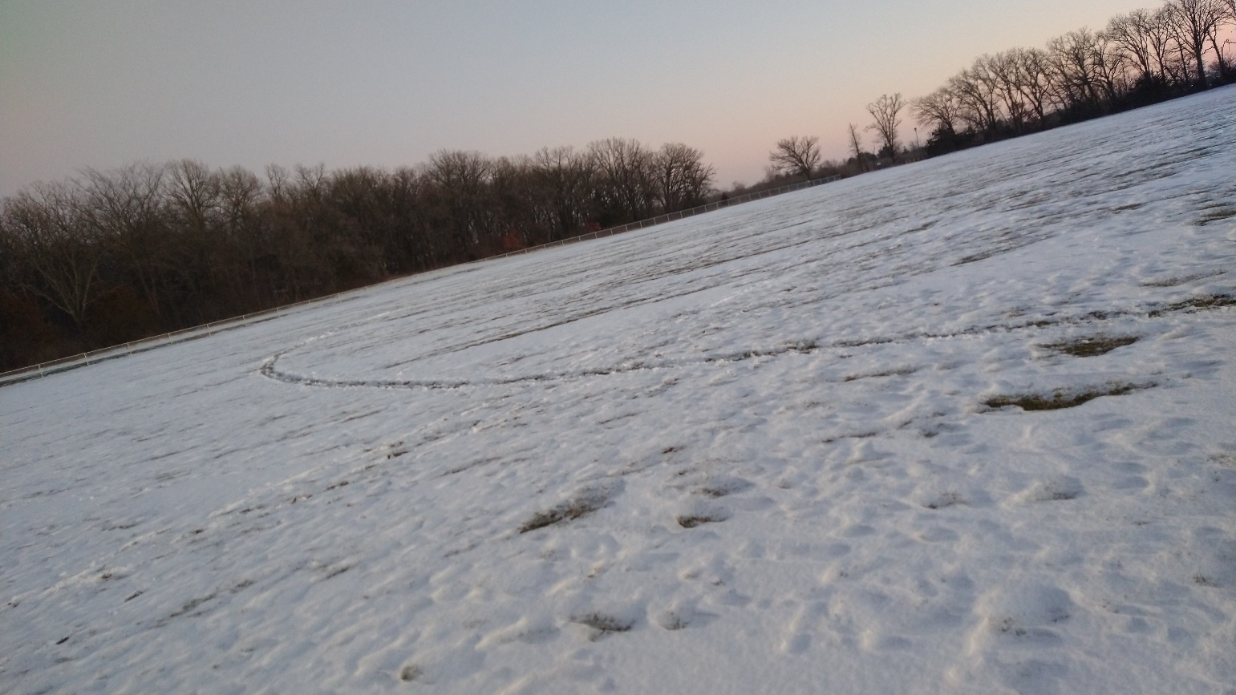

1. Place each client network node on the circle, 45 degrees apart, with the same orientation toward the center

**Figure 10**

*Client nodes*

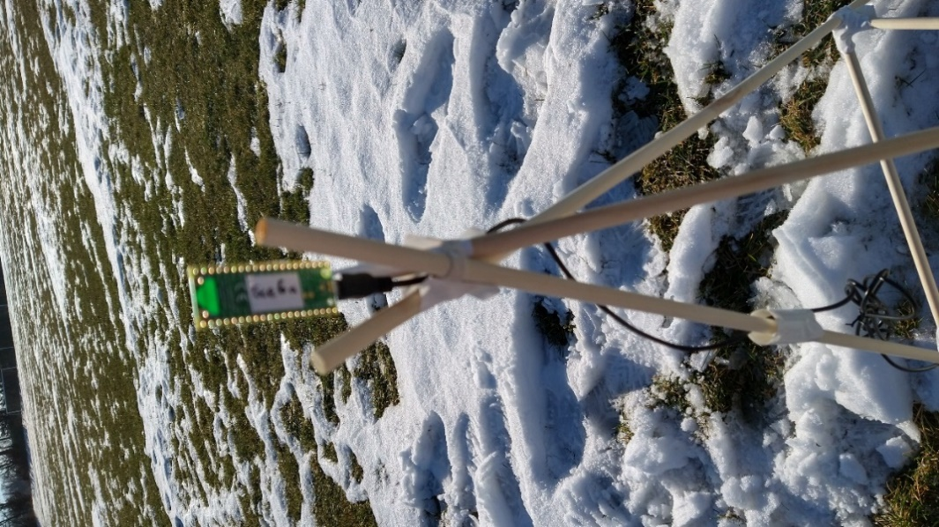

* 1. Find the spacing between two stations using (you are missing the reference here…not saying you need it….the statement is just incomplete)

Answer in our case is roughly 76.5 feet

* 1. Place a station on the north edge of the circle, place the rest of the stations by using the tape measure to make sure they are 76.5 feet apart

**Figure 11**

*Measuring 76.5 feet between client nodes*

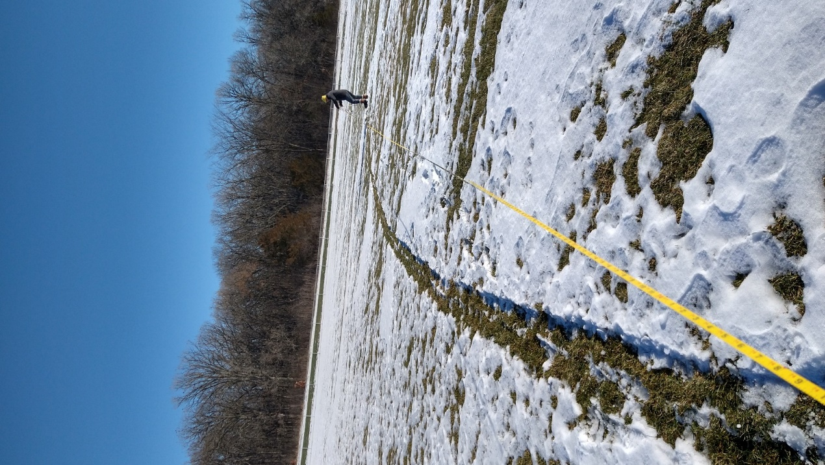

* 1. Record the Media Access Control (MAC) address and location of each client node.

MAC addresses are similar to the house number on a person’s mailing address. It is a unique identifier for one specific Network Interface Controller (NIC) (*What's a MAC address and how do I find it?* 2021). While a device can have more than one NIC and therefore more than one MAC address, the client nodes used only had one NIC and one MAC address.

**Figure 12**

*Location and MAC of client nodes*

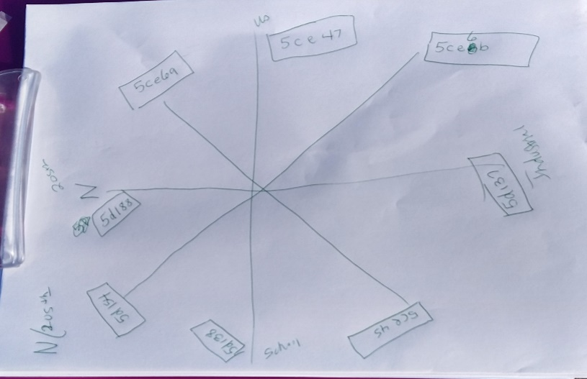

1. Place the card table and 5-gallon bucket in the middle of the circle

**Figure 13**

*Card table and bucket (left), client node (right)*

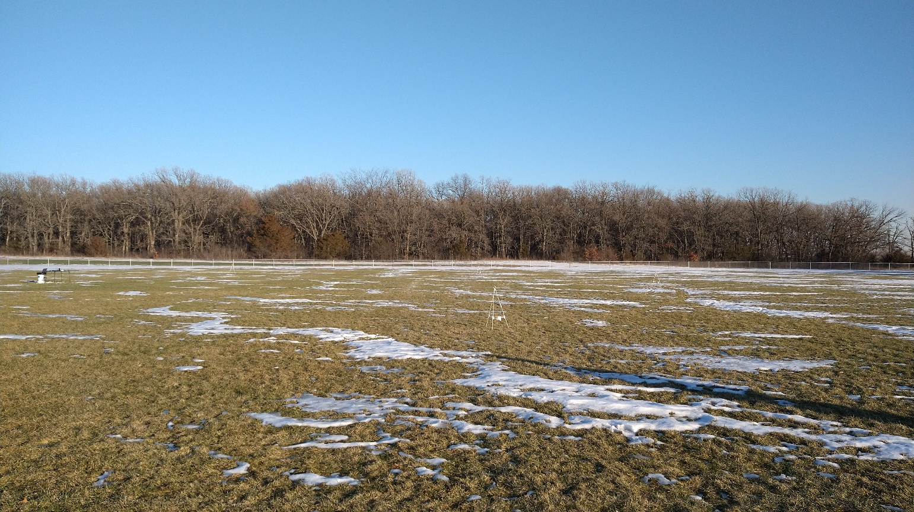

1. Place the UPS on the 5-gallon bucket
2. Place the laptop on top the UPS and plug it in and turn it on.
3. Place the router on the card table and connect the first (dipole) antenna to it and plug it in to the UPS and turn it on.

**Figure 14**

*Card table with router and dipole antenna on table, laptop on UPS*

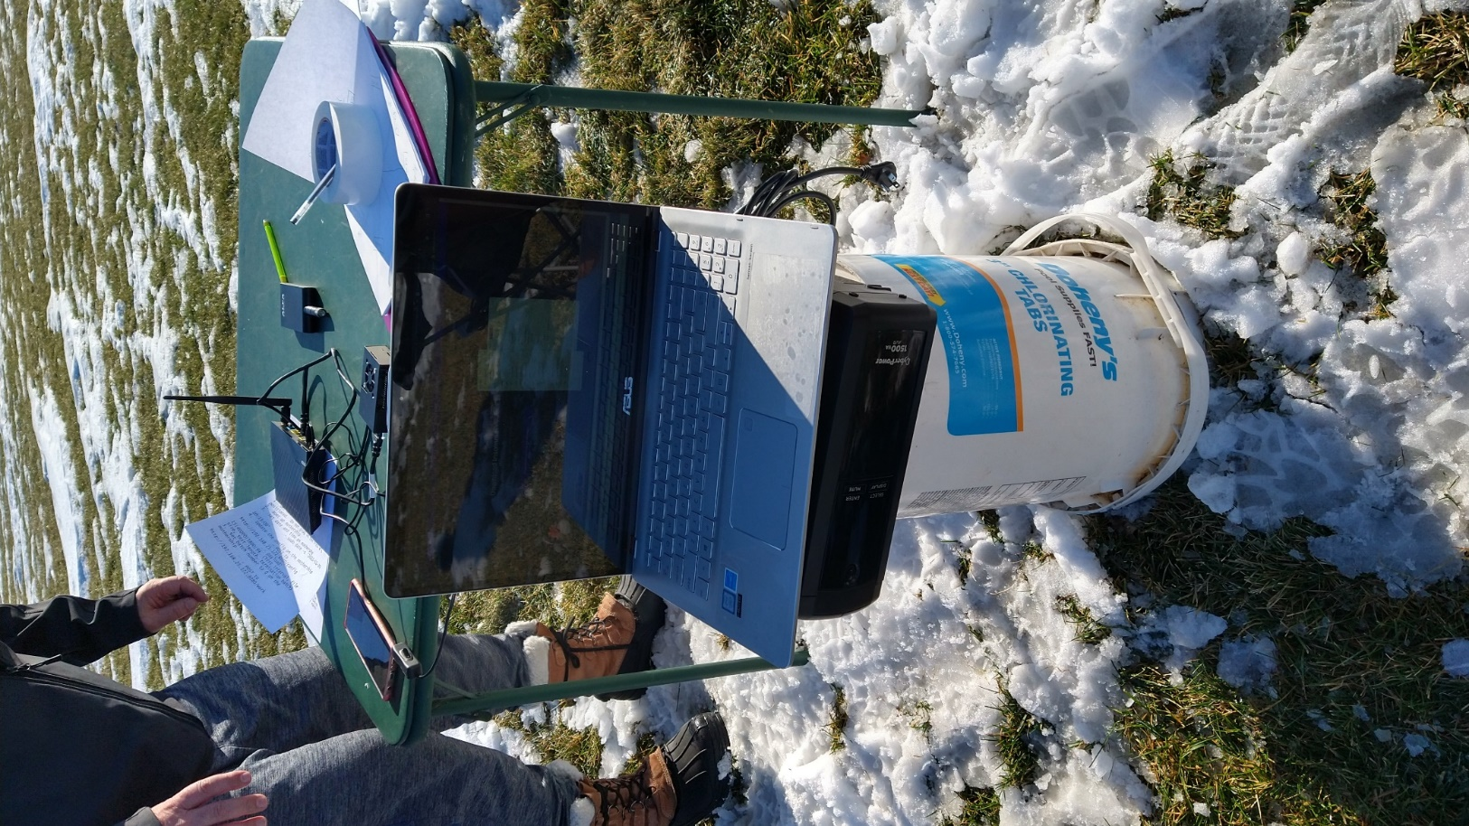

1. Place the server computer on the card table. Connect it to the access point via ethernet cable, plug it into the UPS.
2. Boot up the server computer. The router has been configured to assign it a specific IP address.
3. Connect to the server computer using MRemoteNG (SSH client) from the laptop
4. Set the time on the server computer
   1. sudo (“super user do”) date -s 'YYYY-MM-DD HH:MM:SS'
5. Set up experiment configuration on the server computer using Insomnia
   1. POST to <http://192.168.25.172:8080/config>
      1. Payload: 15|40000|1800|99
         1. sample interval in seconds (15)
         2. transfer file size in bytes (40000)
         3. test length in seconds (1800)
         4. batch number to terminate program (99)
6. Set batch to zero on the server computer using Insomnia
   1. POST to <http://192.168.25.172:8080/work>
      1. Payload: 0
         1. Batch number 0 is what is expected as the starting state by the clients. They will continue to check for work until the batch number changes
7. Walk to each client network node and switch on the power

**Figure 15**

*Battery packs of client nodes being switched on and returned to pouch*

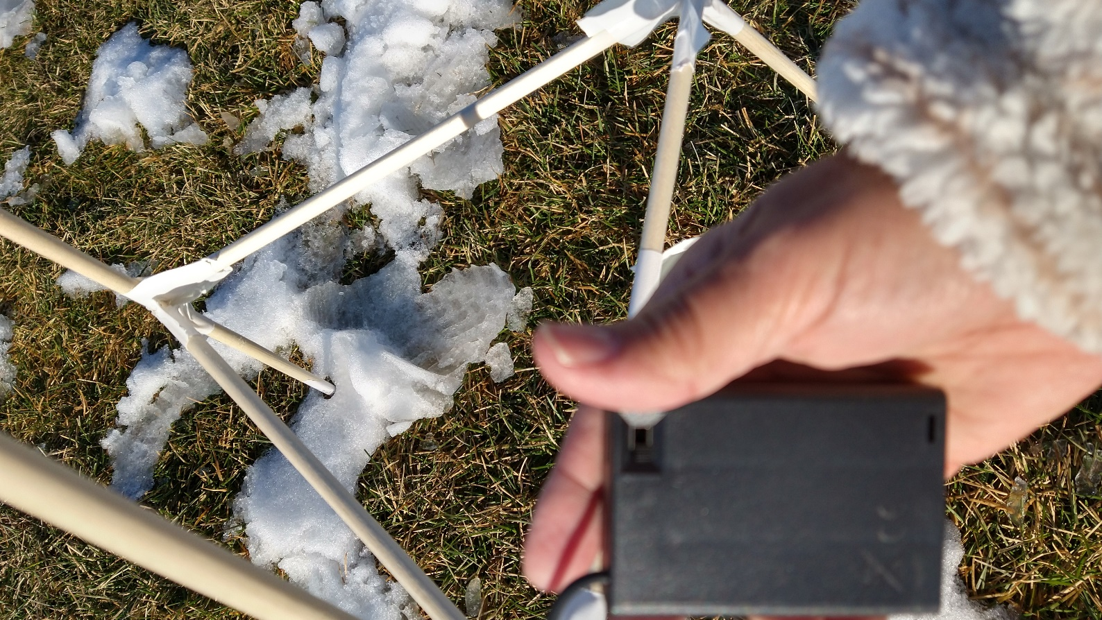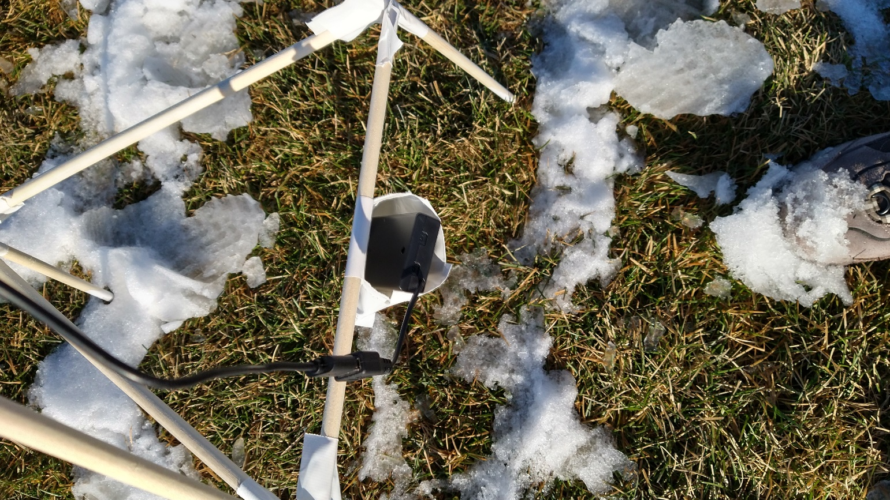

1. Monitor the client network check-ins on the server computer with the laptop
   1. View the perflog.csv file on the server computer, looking for ‘Network Checkin’ from each client computer
2. After all clients have checked in, tell the server computer to begin the experiment using Insomnia
   1. Increase the batch number on the server computer
      1. POST to <http://192.168.25.172:8080/work>
      2. Payload: 1 (increase for each antenna)
3. Monitor the server computer using MRemontNG to view the log of custom program. Watch until all clients finish their work and start requesting new work

**Figure 16**

*Dipole antenna test*

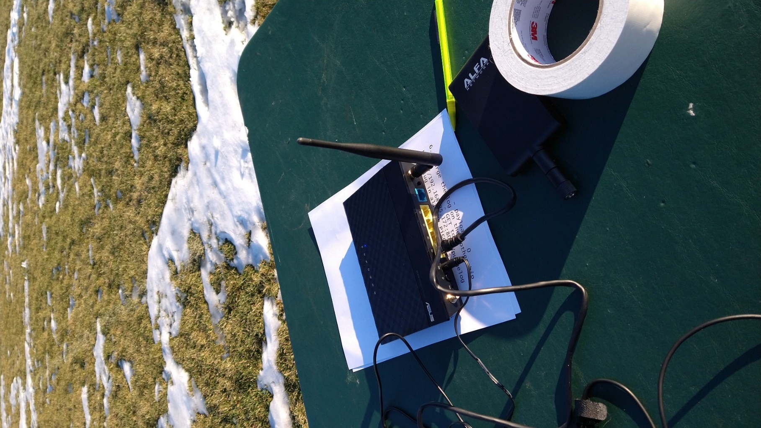

1. Change the antenna. If the antenna has a directional bias, point that due West

**Figure 17**

*Panel antenna test*

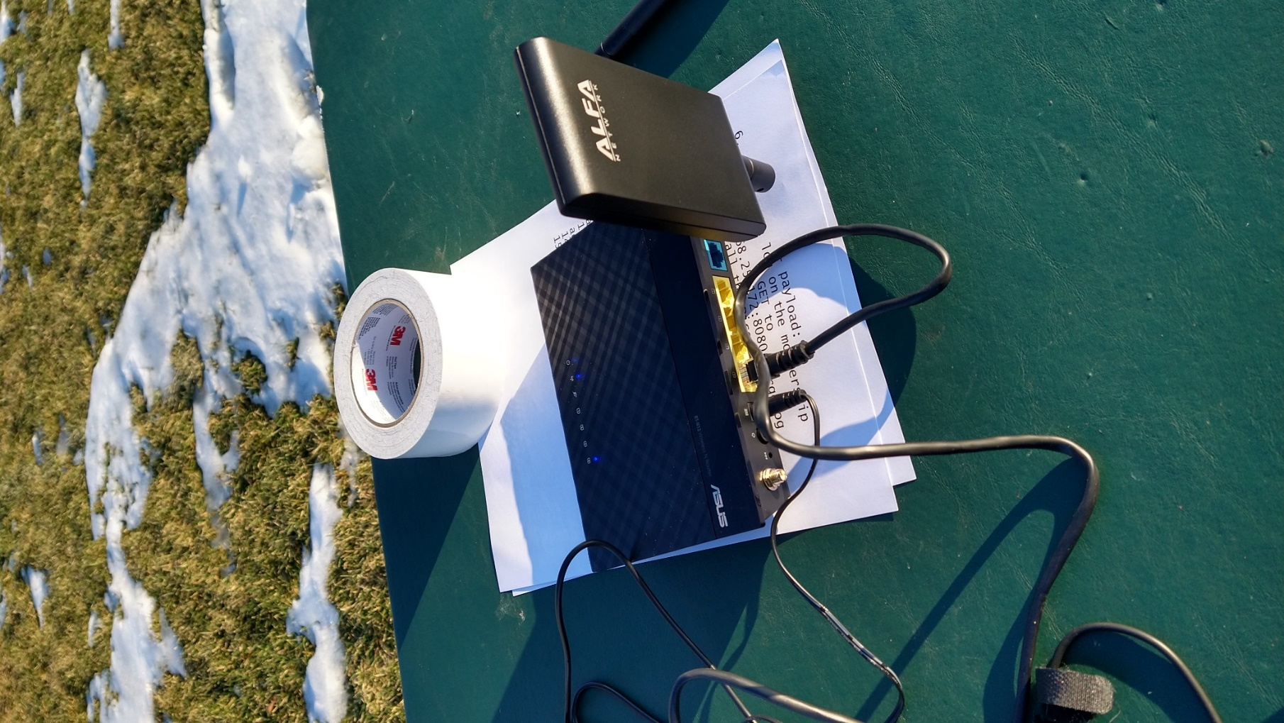

**Figure 18**

*Yagi antenna test*

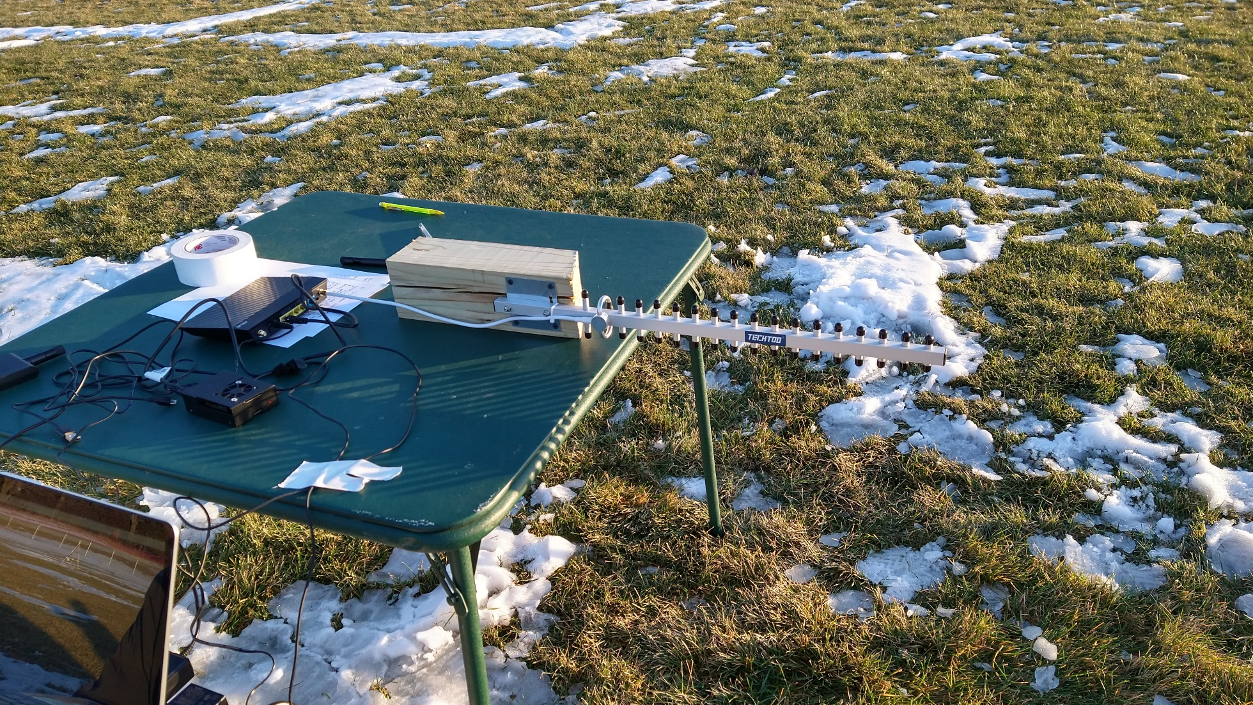

1. Repeat steps 15a-18 until done
2. When all tests are done retrieve and store the log for safekeeping from the laptop using Insomnia
   1. GET to <http://192.168.25.172:8080/showlog>
   2. Save it to a local file on the laptop
3. Shutdown the server computer gracefully using MRemoteNG on the laptop
   1. sudo (“super user do”) shutdown
4. Shut off each client battery pack and collect the stations
5. Shutdown the laptop
6. Shut off UPS by holding button for 10 seconds
7. Collect all materials

# Results

## The Recorded Data

For each fifteen second iteration of the test, the client network nodes sent statistics to the central computer that included the client’s unique MAC address, current batch number, number of milliseconds it took to transfer the sample file and the RSSI value of its wireless network connection.

The server computer added the current date time as an epoch and wrote it to a log file. You can see a portion of the log in figure 19. This sample is from early in the experiment when the nodes were checking in and some metrics from the first test run.

**Figure 19**

*Log file portion*

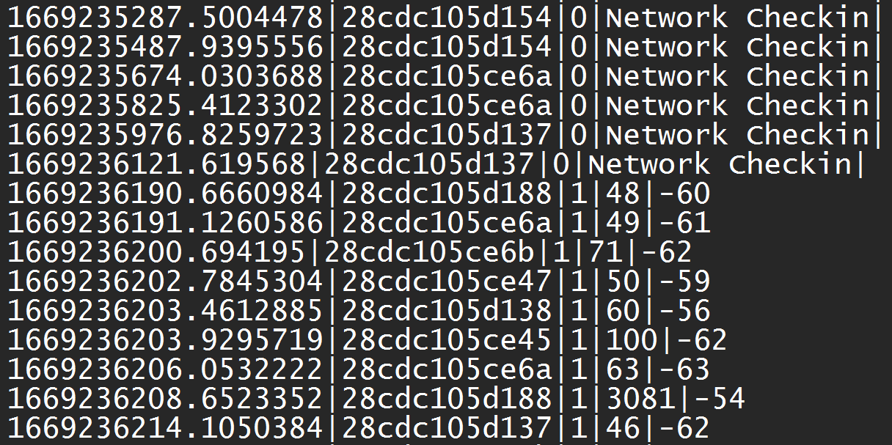

## The Omnidirectional (Dipole) Antenna

The first test was using the dipole antenna. The dipole antenna used for the experiment is rated at a 5dBi gain and was included with the router. For this, and the rest of the tests, only one antenna was installed on the router even though there are two antenna mounts.

Figures 20 and 21, below graph the minimum, maximum, and median RSSI and the minimum, average, and median file transfer time and are presented along with tables 1 and 2 which contain the minimum, maximum, average, and median values for RSS and file transfer time.

**Figure 20**

*Dipole RSSI Results*

**Table 1**

*Dipole RSSI Results*

|  |  |  |  |  |
| --- | --- | --- | --- | --- |
| Dipole RSSI Results | | | | |
| Client | Min | Maxi | Aver | Median |
| North | -72 | -52 | -59.338843 | -59 |
| Northeast | -69 | -61 | -63.7520661 | -64 |
| East | -61 | -55 | -57.3966942 | -57 |
| Southeast | -66 | -58 | -60.7107438 | -61 |
| South | -68 | -60 | -62.1487603 | -62 |
| Southwest | -76 | -61 | -64.7916667 | -64.5 |
| West | -63 | -53 | -56.5867769 | -56 |
| Northwest | -73 | -54 | -64.4876033 | -65 |

**Figure 21**

*Dipole File Transfer Results*

**Table 2**

|  |  |  |  |  |
| --- | --- | --- | --- | --- |
| Dipole File Transfer Results  (Maximum file transfer time was excluded from the graph as it made the visual useless) | | | | |
| Client | Min | Max | Aver | Median |
| North | 41 | 3081 | 86.58677686 | 53 |
| Northeast | 43 | 184 | 62.80991736 | 54 |
| East | 42 | 134 | 55.66115702 | 50 |
| Southeast | 42 | 344 | 60.90909091 | 52 |
| South | 44 | 349 | 68.76859504 | 56 |
| Southwest | 43 | 125 | 62.99166667 | 59.5 |
| West | 41 | 387 | 67.04958678 | 50 |
| Northwest | 41 | 1395 | 74.33057851 | 56 |

*Dipole File Transfer Results*

### Dipole Results

The results of the dipole test show a relatively uniform file transfer time with a slight northwest and east bias on signal strength. A dipole antenna is supposed to be omnidirectional so the results for the minimum RSSI reading on the dipole are somewhat surprising. That said, when viewed through the median function, the RSSI distribution looks uniform.

## Semi-Directional Antenna (Panel)

For the semi-directional test, a panel antenna from Alfa Networks was selected. It is rated for an 8dBi gain on 2.4GHz and specifies a 66-degree horizontal beam and a 16-degree vertical beam coverage *(APA-M25*, n.d.) . The panel antenna was installed in place of the dipole antenna and the same experiment was run.

Figures 22 and 23 graph the minimum, maximum, and median RSSI and the minimum, average, and median file transfer time and are presented along with tables 3 and which contain the minimum, maximum, average, and median values for RSS and file transfer time.

**Figure 22**

*Panel RSSI Results*

**Table 3**

*Panel RSSI Results*

|  |  |  |  |  |
| --- | --- | --- | --- | --- |
| Panel RSSI Results | | | | |
| Client | Min | Max | Aver | Median |
| North | -82 | -63 | -67.45454545 | -67 |
| Northeast | -95 | -73 | -77.66115702 | -77 |
| East | -88 | -63 | -71.40495868 | -71 |
| Southeast | -95 | -73 | -75.87603306 | -75 |
| South | -97 | -69 | -73.73333333 | -73 |
| Southwest | -64 | -55 | -57.28099174 | -57 |
| West | -57 | -48 | -49.9338843 | -50 |
| Northwest | -75 | -58 | -59.6446281 | -59 |

**Figure 23**

*Panel File Transfer Results*

**Table 4**

*Panel File Transfer Results*

|  |  |  |  |  |
| --- | --- | --- | --- | --- |
| Panel File Transfer Results  (Maximum file transfer time was excluded from the graph as it made the visual useless) | | | | |
| Client | Min | Max | Aver | Median |
| North | 43 | 3469 | 102.1652893 | 59 |
| Northeast | 53 | 541 | 142.3966942 | 81 |
| East | 46 | 343 | 68.70247934 | 59 |
| Southeast | 46 | 545 | 98.72727273 | 62 |
| South | 46 | 492 | 94.08333333 | 58 |
| Southwest | 42 | 149 | 56.23966942 | 48 |
| West | 42 | 337 | 62.37190083 | 51 |
| Northwest | 42 | 114 | 53.18181818 | 47 |

### Semi-Directional Antenna Results

The RSSI test favored the direction the antenna was pointed with the RSSI being much stronger to the West of the test area than any other. It is also interesting to look at the minimum values for the RSSI as they exaggerate the effect even more. The file transfer tests show the average speed to the northeast client to be much slower than the rest. This is also somewhat true of the median. These are caused by bad transfer times on some of the repetitions. Overall, the minimum and median file transfer times show a fairly balanced performance for all clients.

## A ”More” Directional Antenna (Yagi)

The final antenna used in this test was a Yagi. The Yagi was rated for an 18 dBi gain (*TECHTOO WIFI 2.4ghz 18dbi high gain Yagi directional ...,* n.d.) . The horizontal beam width was rated at 30 degrees and the vertical beam width was rated at 28 degrees. On paper, it has a narrower horizontal beam and a greater gain rating than the panel antenna. The Yagi antenna was installed in place of the panel antenna and the same experiment was run.

Figures 24 and 25 graph the minimum, maximum, and median RSSI and the minimum, average, and median file transfer time and are presented along with tables 5 and 6 which contain the minimum, maximum, average, and median values for RSS and file transfer time.

**Figure 24**

*Yagi RSSI Results*

**Table 5**

*Yagi RSSI Results*

|  |  |  |  |  |
| --- | --- | --- | --- | --- |
| Yagi RSSI Results | | | | |
| Client | Min | Max | Aver | Median |
| North | -75 | -60 | -62.09166667 | -62 |
| Northeast | -91 | -71 | -73.78512397 | -73 |
| East | -87 | -61 | -65.00826446 | -64 |
| Southeast | -93 | -69 | -72.88429752 | -72 |
| South | -97 | -68 | -71.88429752 | -71 |
| Southwest | -61 | -55 | -56.4 | -56 |
| West | -50 | -42 | -43.84297521 | -44 |
| Northwest | -76 | -63 | -65.67768595 | -65 |

**Figure 25**

*Yagi File Transfer Results*

**Table 6**

*Panel File Transfer Results*

|  |  |  |  |  |
| --- | --- | --- | --- | --- |
| Yage File Transfer Results  (Maximum file transfer time was excluded from the graph as it made the visual useless) | | | | |
| Client | Min | Max | Aver | Median |
| North | 42 | 2913 | 100.6333333 | 62 |
| Northeast | 48 | 1883 | 163.107438 | 87 |
| East | 42 | 1499 | 87.15702479 | 61 |
| Southeast | 45 | 685 | 101.2644628 | 69 |
| South | 43 | 1368 | 84.90082645 | 66 |
| Southwest | 42 | 1655 | 74.225 | 53.5 |
| West | 41 | 333 | 68.17355372 | 58 |
| Northwest | 42 | 164 | 64.3553719 | 54 |

### Yagi Antenna Results

The RSSI strongly favored the orientation of the antenna. This antenna produces a much stronger signal in one direction than in the others. The minimums once again exaggerate the effect, but it is clear without looking at them. File transfer tests show the average speed to the northeast client to be much slower than the rest. This is also somewhat true of the median. A few bad transfer times during the test impacted the aggregate function (average) but a few examples should not have greatly affected the median. There is worse performance in this direction than in the other two antennas.

## Comparing the antennas

### RSSI

Figure 26 shows the median RSSI for all the antennas. The strongest directional signal difference is shown by the Yagi. It also, however, does nearly as well as the panel in all other directions, even beating it out in the opposite direction of the point. This is probably due to its greater gain rating but that does not fully explain how it performed with the Northwest client node.

The dipole antenna shows the most balanced results. This is to be expected as dipole antenna are omnidirectional.

**Figure 26**

*All Antennas RSSI Results*

### File Transfer Time

Figure 27 shows the median file transfer time all the antennas. The file transfer times tell an interesting story as well. The dipole is once again the most balanced performance across all the clients. The Yagi, while having a stronger received signal strength in some instances than the panel, always turned in poorer file transfer performance. This is possibly due to antenna or physical connection quality that lowered the signal to noise ratio, but this experiment was not designed to measure that.

**Figure 27**

*All Antennas File Transfer Results*

# Conclusion

The hypothesis is confirmed. Captured metrics on RSSI and file transfer times clearly show that there is a difference in the strength of a wireless signal and network throughput based on antenna type and network client location relative to the access point antenna. The differences are most pronounced between the front (West) and back (East) side RSSI values noted on the more directional antenna. The file transfer test showed a difference, but it was not as pronounced excepting for the Northeast client. This may be due to the limited size of the file which was imposed by the RAM available in the network client.

# References:

Ali, M. (2021). *Reconfigurable antenna design and analysis*. Artech House.

*All you need to know about VNC remote access technology*. Real VNC. (2022). Retrieved December 10, 2022, from https://discover.realvnc.com/what-is-vnc-remote-access-technology

*Antenna theory - micro strip*. Tutorials Point. (n.d.). Retrieved December 7, 2022, from https://www.tutorialspoint.com/antenna_theory/antenna_theory_micro_strip.htm#:~:text=The%20radiation%20pattern%20of%20microstrip,It%20has%20lesser%20directivity.

*APA-M25*. ALFA Network Inc. (n.d.). Retrieved December 10, 2022, from https://www.alfa.com.tw/products/apa-m25?variant=36473963839560

Capano, D. E. (2014). Antenna basics, antenna types, antenna functions. *Control Engineering*, *61*(9), 18+. <https://link.gale.com/apps/doc/A387827229/AONE?u=vol_b92c&sid=googleScholar&xid=689f8ab7>

*CP1500AVRLCD*. CyberPower. (2022). Retrieved December 8, 2022, from https://www.cyberpowersystems.com/product/ups/intelligent-lcd/cp1500avrlcd/

*Find, install and publish python packages with the python package index*. PyPI. (n.d.). Retrieved December 10, 2022, from https://pypi.org/

Hardson-Hurley, K. (n.d.). *Thonny: The beginner-friendly python editor*. Real Python. Retrieved December 10, 2022, from https://realpython.com/python-thonny/

Manjaly, S. (2022, August 29). *MRemoteNG: Using the remote connections manager for Windows*. IT Management Software. Retrieved December 10, 2022, from https://blog.invgate.com/mremoteng#:~:text=What%20is%20mRemoteNG%3F,(SSH)%2C%20and%20others.

*Mitra , D. (2021, October 21). Understanding insomnia rest client made easy 101 - learn. Hevo Data. Retrieved December 10, 2022, from https://hevodata.com/learn/insomnia-rest-client/#:~:text=Insomnia%20REST%20client%20is%20a%20Free%20Cross%2DPlatform%20Desktop%20Framework,and%20HTTP%2Dbased%20RESTful%20APIs.*

*New Pi Pico W- WIFI features, Specs & Pinout Simplified*. eTechnophiles. (2022). Retrieved December 8, 2022, from https://www.etechnophiles.com/raspberry-pi-pico-w-wifi-specs-pinout/

Ohio State University. (2021, January 16). *What's a MAC address and how do I find it?* Technology Services. Retrieved December 1, 2022, from <https://slts.osu.edu/articles/whats-a-mac-address-and-how-do-i-find-it/>

*Raspberry pi os*. Raspberry Pi. (n.d.). Retrieved December 10, 2022, from https://www.raspberrypi.com/software/

*Raspberry pi 4 GPIO pinout, Specs, schematic (detailed board layout)*. eTechnophiles. (2021). Retrieved December 8, 2022, from https://www.etechnophiles.com/raspberry-pi-4-gpio-pinout-specifications-and-schematic/

*RT-N12 D1*. RT-N12 D1 - Tech Specs｜WiFi Routers｜ASUS USA. (n.d.). Retrieved December 10, 2022, from https://www.asus.com/us/networking-iot-servers/wifi-routers/asus-wifi-routers/rtn12_d1/techspec/

*TECHTOO WIFI 2.4ghz 18dbi high gain yagi directional ...* Amazon. (n.d.). Retrieved December 11, 2022, from https://www.amazon.com/TECHTOO-Directional-Connector-Wireless-Extension/dp/B00OCJYPCY

Westcott, D. A., & Coleman, D. D. (2014). *Cwna: Certified Wireless Network Administrator Official Study Guide: Exam Cwna-106*. Sybex. Retrieved November 23, 2022, from https://learning-oreilly-com.cobalt.champlain.edu/library/view/cwna-certified-wireless/9781118896129/.

*Yagi antenna / Yagi-Uda Aerial*. Electronics Notes. (n.d.). Retrieved December 7, 2022, from https://www.electronics-notes.com/articles/antennas-propagation/yagi-uda-antenna-aerial/basics-overview.php#:~:text=The%20Yagi%20antenna%20exhibits%20a,the%20direction%20of%20the%20reflector.

*Yagi antenna gain, Directivity & Front to back ratio*. Electronics Notes. (n.d.). Retrieved December 7, 2022, from https://www.electronics-notes.com/articles/antennas-propagation/yagi-uda-antenna-aerial/gain-directivity.php

# Appendix

## Raw data collected during the test



## Spreadsheet with data and graph sources



## Program from network client



## Program from server computer



## Webserver.py Endpoint Information

The Python program webserver.py is used to configure the experiment, control work for the clients, and log metrics for the clients. In order to do so, it presents a few web service endpoints as follows:

### Post Endpoints

#### /metrics

The metrics endpoint takes a payload and writes it to a file (perflog.csv) added by the server computer’s current epoch. It returns the current epoch as a result. This endpoint is called by the clients to log their results. The payload for the metrics endpoint is a simple pipe delimited body containing

* Client MAC Address
* Current batch I
* File transfer time in milliseconds
* RSSI of the last scan by the endpoint

#### /work

The work endpoint takes a number and sets the current batch to this number. It returns current epoch as a result. This endpoint is used by the controlling computer to signal that there is new work to do to the clients. The payload is a simple number

* New batch number

#### /config

The config endpoint sets the configuration for the test. It takes a simple pipe delimited payload including the following parameters in order. It returns the current epoch. This endpoint is used by the controlling computer to set the parameters for the test.

* + - * Sample interval in seconds
      * Transfer file size in bytes
      * Test length in seconds
      * Batch number to terminate program

### Get Endpoints

#### /config

Returns a simple pipe-delimited body with the test configuration and the current server time. It contains:

* + - * Sample interval in seconds
      * Transfer file size in bytes
      * Test length in seconds
      * Batch number to terminate program
      * Current server epoch

#### /work

Returns the current batch and current server epoch as a pipe delimited body. This is called by the client computers when they are done processing their current batch. They will call this until it returns a new batch number to be worked or the terminate batch number

* Current batch number
* Current server epoch

#### /purgelog

Deletes the performance log, returns current epoch. This is called by the controlling computer if it desires to delete the current experiment log. Danger….this will delete all your experiment results to date.

#### /showlog

Returns the experiment performance log that has been created by the clients calling the metrics endpoint during their test. Each line in the file consists of the following and is pipe delimited

* Server epoch of metric
* MAC ID of client
* Batch Id
* File transfer time in milliseconds
* RSSI at client

## Determining spacing between client stations

<https://www.quora.com/How-does-one-calculate-the-straight-line-distance-between-two-points-on-a-circle-if-the-radius-and-arc-length-are-known>.